Facebook
Text Examples for Facebook
My SPARK Learning Lab from @indianasparklearninglab is coming to I-LEAD this Fall!

My SPARK Learning Lab provides Hoosier early education and care programs the ability to:
- Complete the Indiana Self-Assessment Tool (I-SAT), a program-level assessment to help program leaders identify areas of growth and receive the support they need.
- Access the SPARK Knowledge Center which includes tools, templates, resources, and so much more.
- Engage with the SPARK Learning Lab Support Team by chat, phone, or email.
… all from your I-LEAD account!

Be on the lookout for more information about My SPARK Learning Lab in the coming weeks!

Images to include in Facebook post

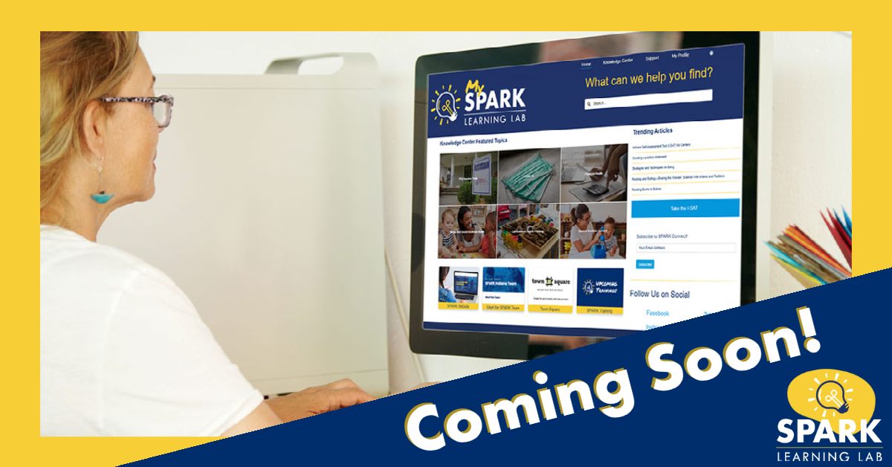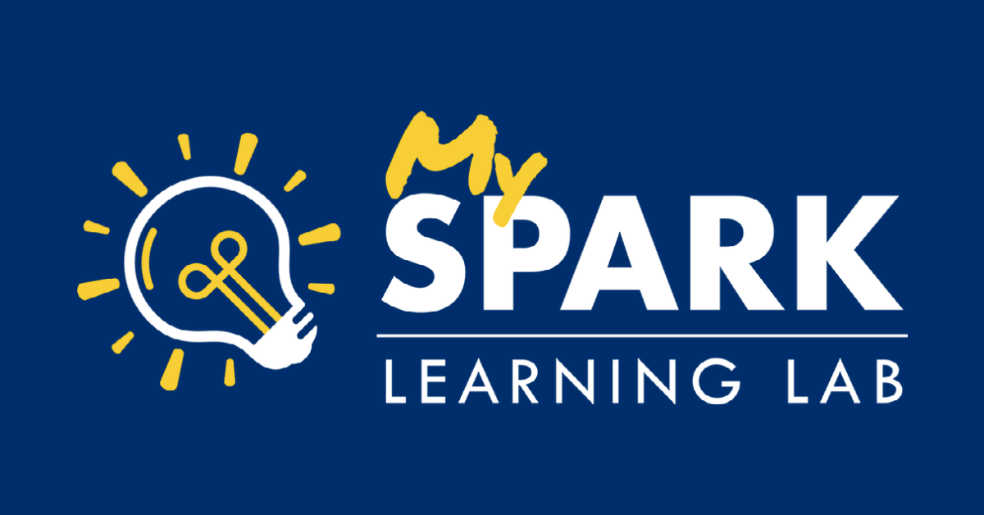
Instagram
Text Examples for Instagram
My SPARK Learning Lab from @indiana_spark is coming to I-LEAD this Fall!

My SPARK Learning Lab provides Hoosier early education and care programs the ability to:
- Complete the Indiana Self-Assessment Tool (I-SAT), a program-level assessment to help program leaders identify areas of growth and receive the support they need.
- Access the SPARK Knowledge Center which includes tools, templates, resources, and so much more.
- Engage with the SPARK Learning Lab Support Team by chat, phone, or email.
… all from your I-LEAD account!

Be on the lookout for more information about My SPARK Learning Lab in the coming weeks!

#IndianaSPARK #SPARKOn

Images to include in Instagram post
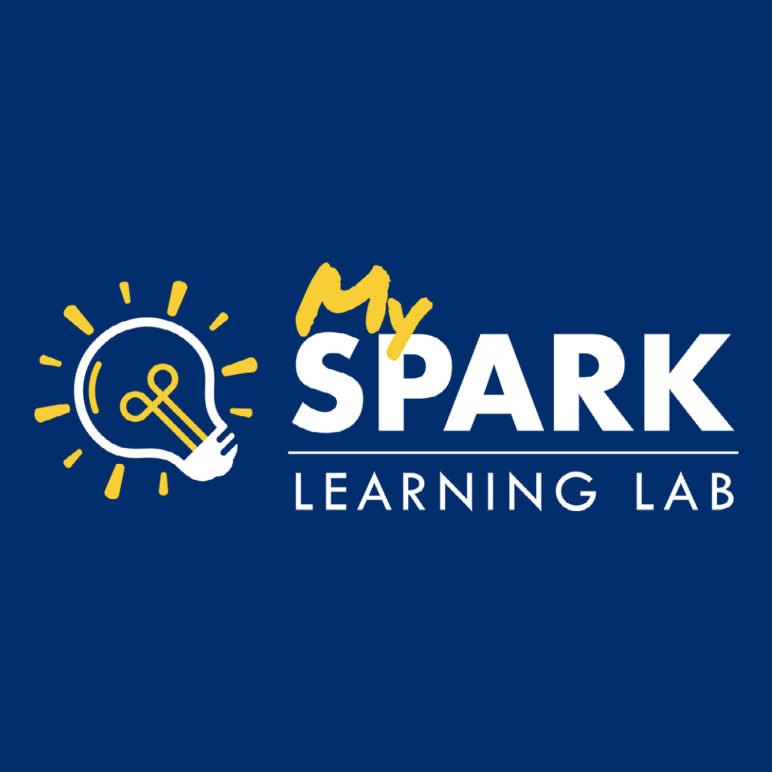

Twitter
Text Examples for Twitter
My SPARK Learning Lab from @indiana_spark is coming to I-LEAD this Fall!

My SLL provides early education and care programs the ability to complete the I-SAT, access the knowledge center, and engage with SPARK Support!

Be on the lookout for more information in the coming weeks!

Images to include in Twitter Post

